

PayPal HackerRank Assessment Shortlists - 2025 Graduates

1 message

Arun Sarma (CW) [**<asarma@paypal.com>**](mailto:asarma@paypal.com) **Wed, 25Nov, 2023 at 4:39 pm**

Dear Candidate,

Greetings from PayPal University Team & we hope you are doing well!

We have recently completed the HackerRank assessments, followed by a comprehensive internal rubric screening (recruiter review) to identify and shortlist top talent from our PAN-India outreach. Hence, we are happy to write to you that you have been shortlisted for the upcoming interview process with PayPal. Please find the below details on the interview process:

Interview Schedule:

Role shortlisted for: Software Engineer Intern Interview Date: 1st Dec 2023

Interview Time: The interview invite with time slot will be sent to your registered email id.

 Virtual Interview Process:

* **Round 1 : Technical Round (1 hour)**
* **Round 2 : Manager Round (1 hour)**

# All the very best for the upcoming interviews!

**As part of the selection process, we will be scheduling interviews.** We request your conﬁrmation on the availability at the earliest. Conﬁrm before 4pm, 27th November 2023**. This will allow us to proceed with the scheduling of interviews and ensure a seamless process. Feel free to reach out for any queries.**

Regards

# Arun P Sarma

University Recruitment Coordinator, Global Talent Acquisition

Mobile: 7411517820

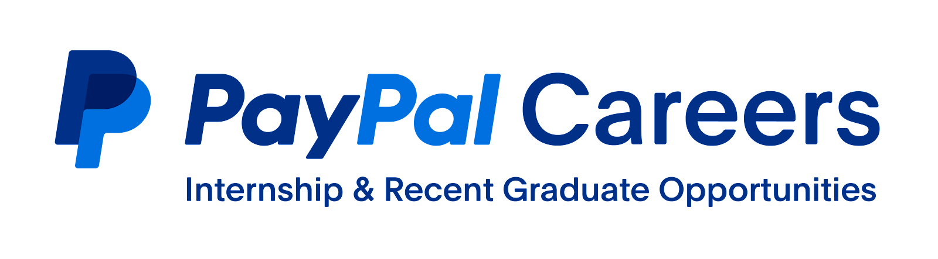

**RGA Tech Park. Block-1, 2nd Floor,**

**31/1, Sarjapur Main Road, Chikkannalli Village,**

**Varthur Hobli, Bangalore-560035.**

**Karnataka, India**